DCourse: CSE 204 – Computer Networks
LAB 5 – VLAN Trunking & DHCP & Static Routing
Due date: May 21st, 2025

Student name | Nguyen Xuan Huan
Student ID | 2131200077

Goal
- Ability to configure VLAN Trunking on Switch
- Ability to configure DHCP on Router.
- Students know how to connect 2 router using Serial Interface
- Ability to configure static routing

Assignment list
II.1 VLAN Trunking Configuration
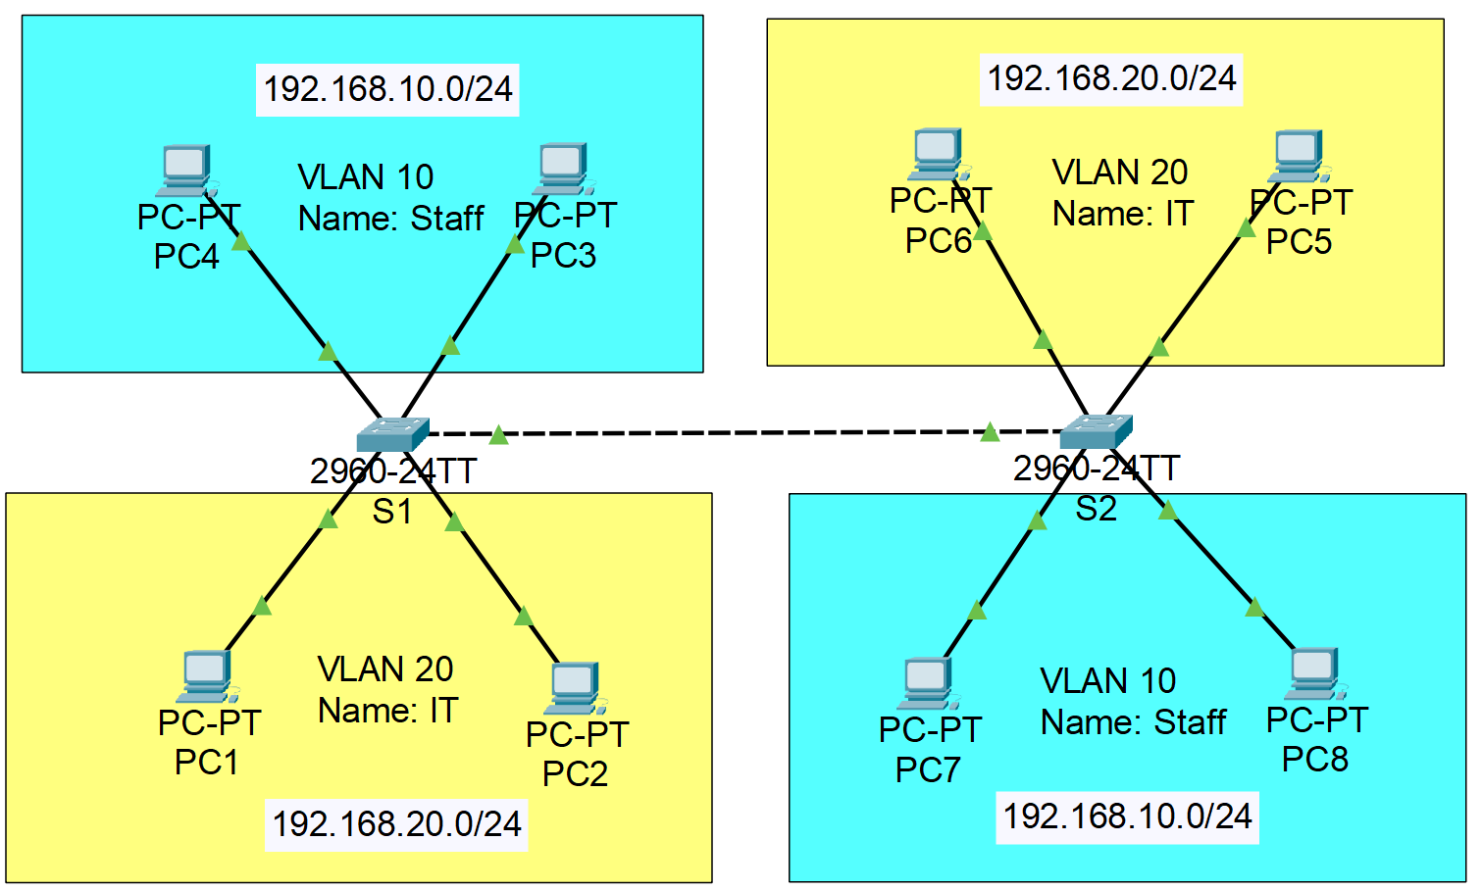
- Note:
  - VLAN 10: port 4, 5
  - VLAN 20: port 7, 8
  - Trunk: port 15
- Step 1: Configure IP for all PCs
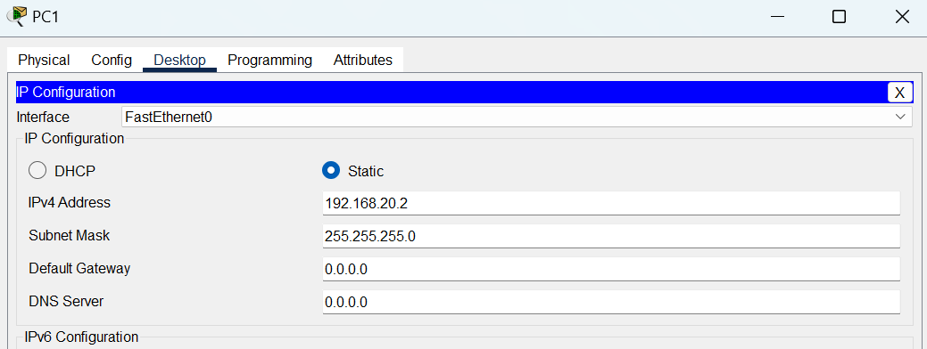
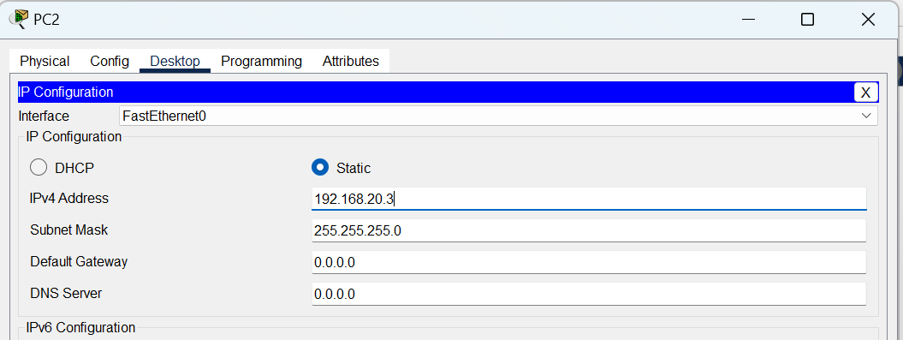
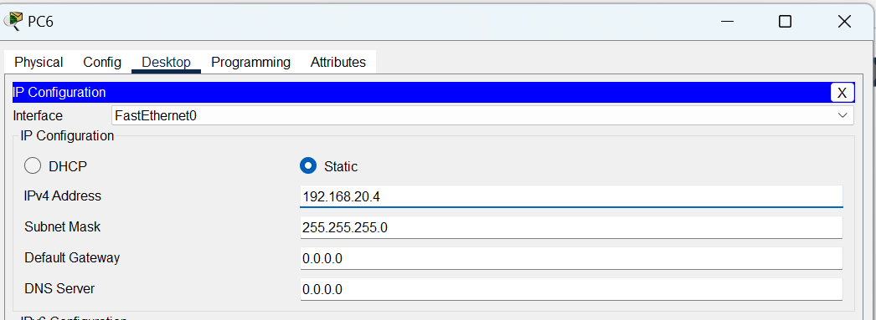
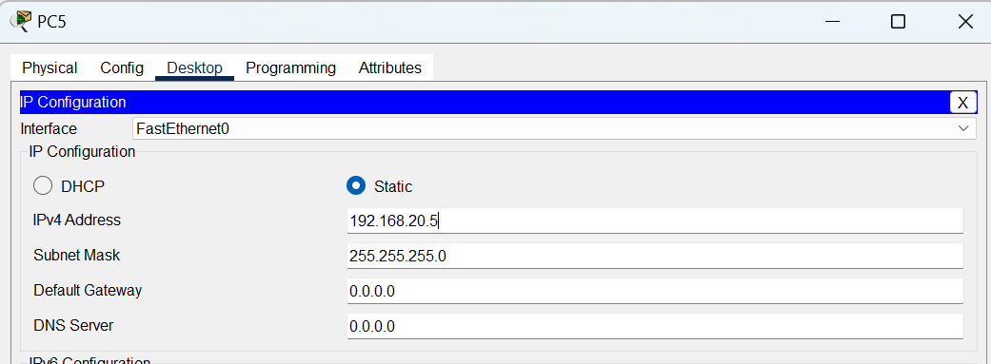
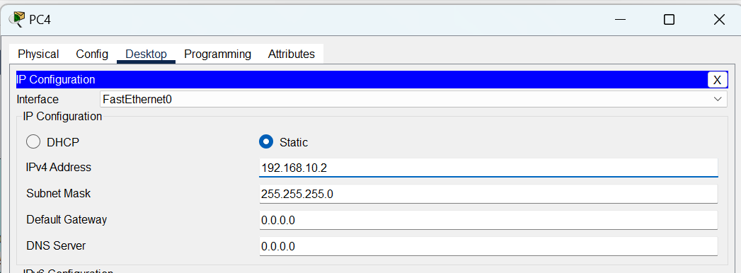
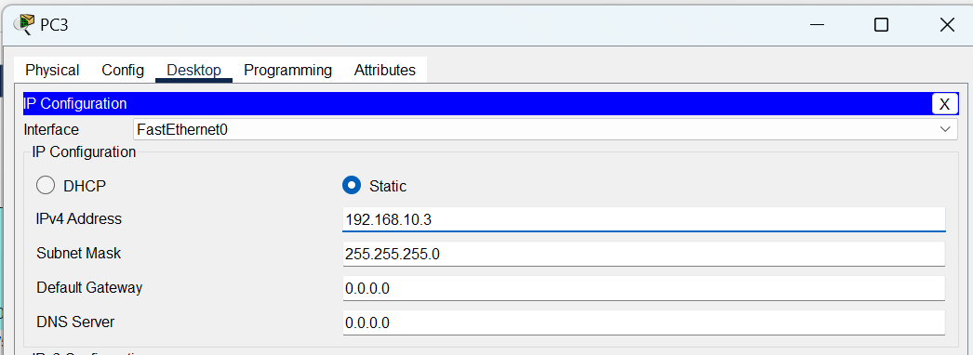
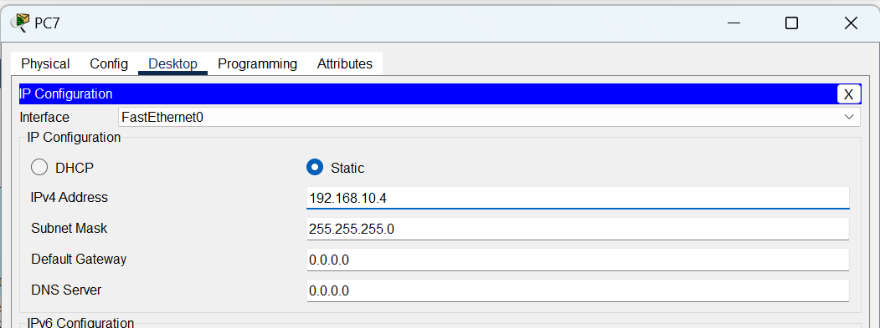
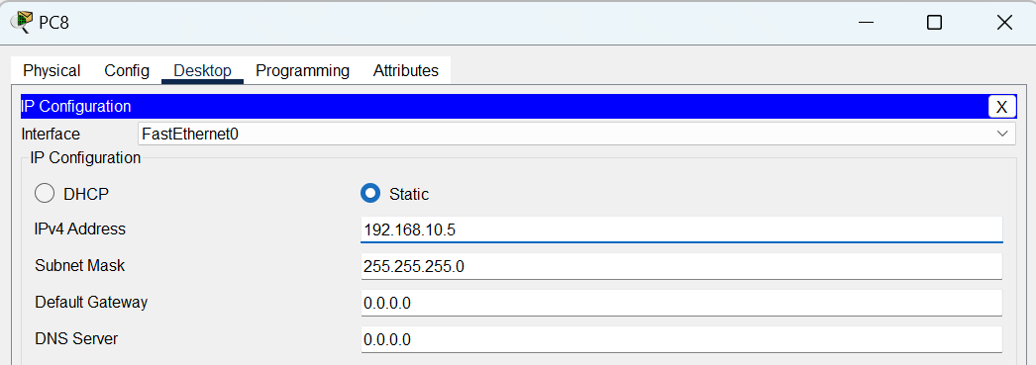
- Step 2: Create VLANs on 2 Switches S1 and S2
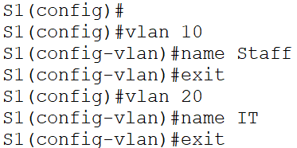
  - Repeat these steps on Switch S2. Result:
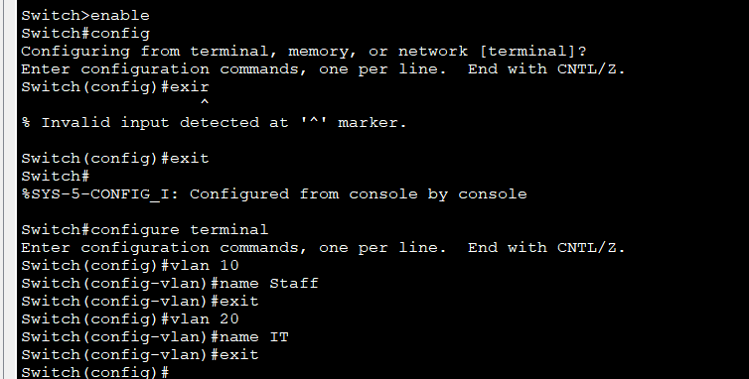
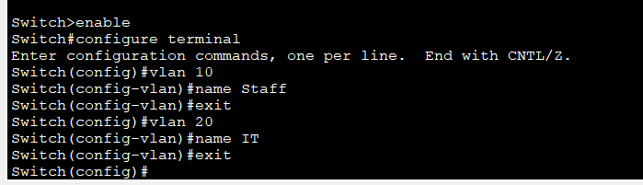

- Step 3: Assign ports to VLAN 10 and VLAN 20
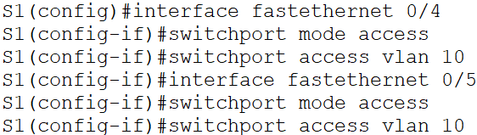
  - Repeat these steps for Switch 2. Result:
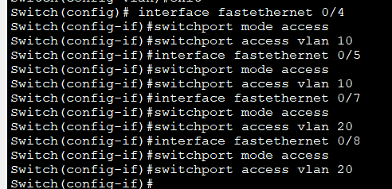
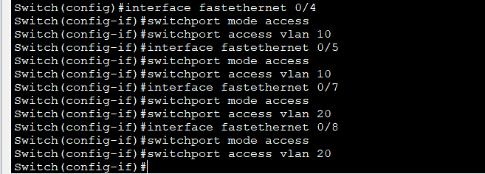
- Step 4: Check connection between PCs
  - Ping PC1 and PC5, then explain the result. Result:
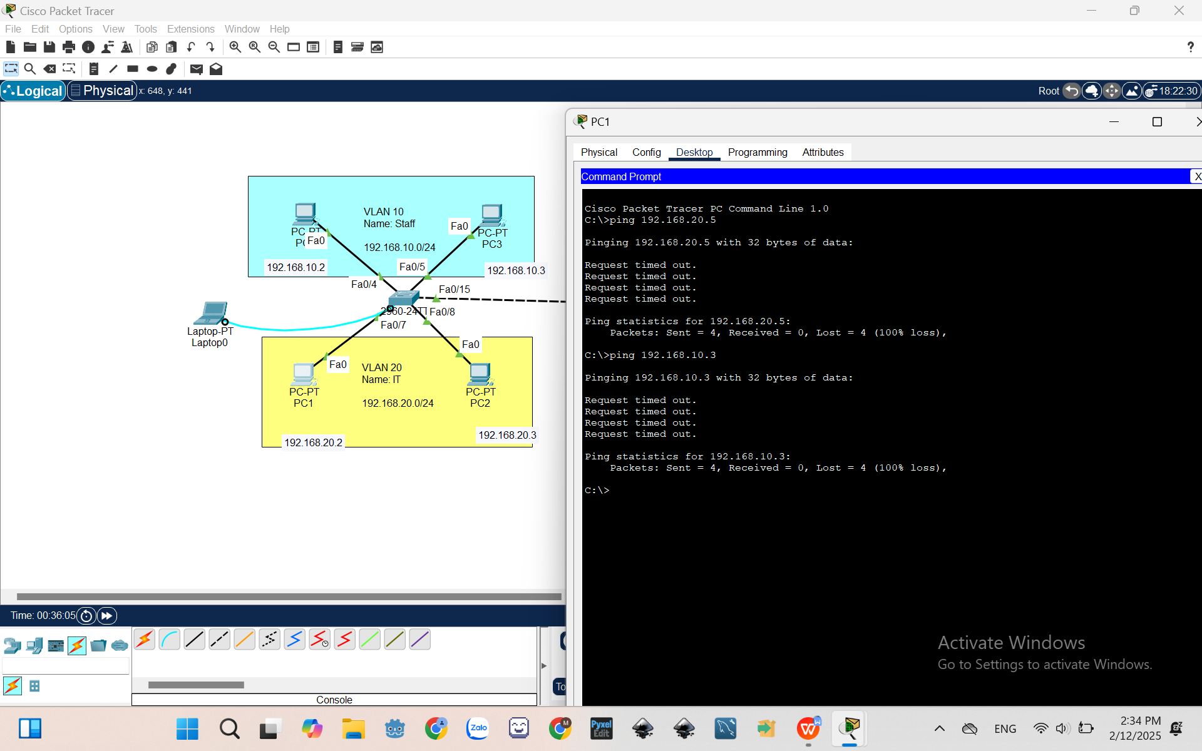
Because 2 switches are not trunking
  - Ping PC1 and PC3, then explain the result. Result:
Because 2 switches are not trunking
- Step 5: Create Trunk ports
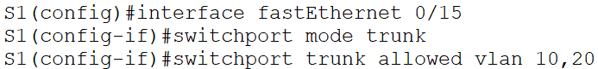
  - Repeat these steps on Switch S2. Result:
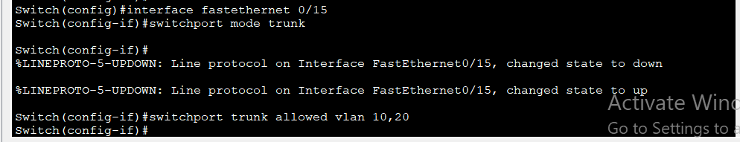
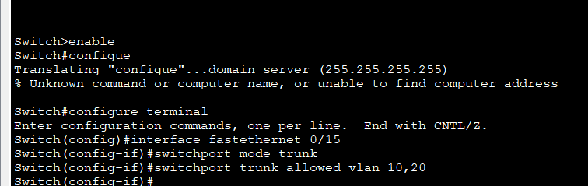
- Step 6: Check connection between PCs after creating Trunk ports
  - Ping PC1 and PC5, then explain the result. Result:
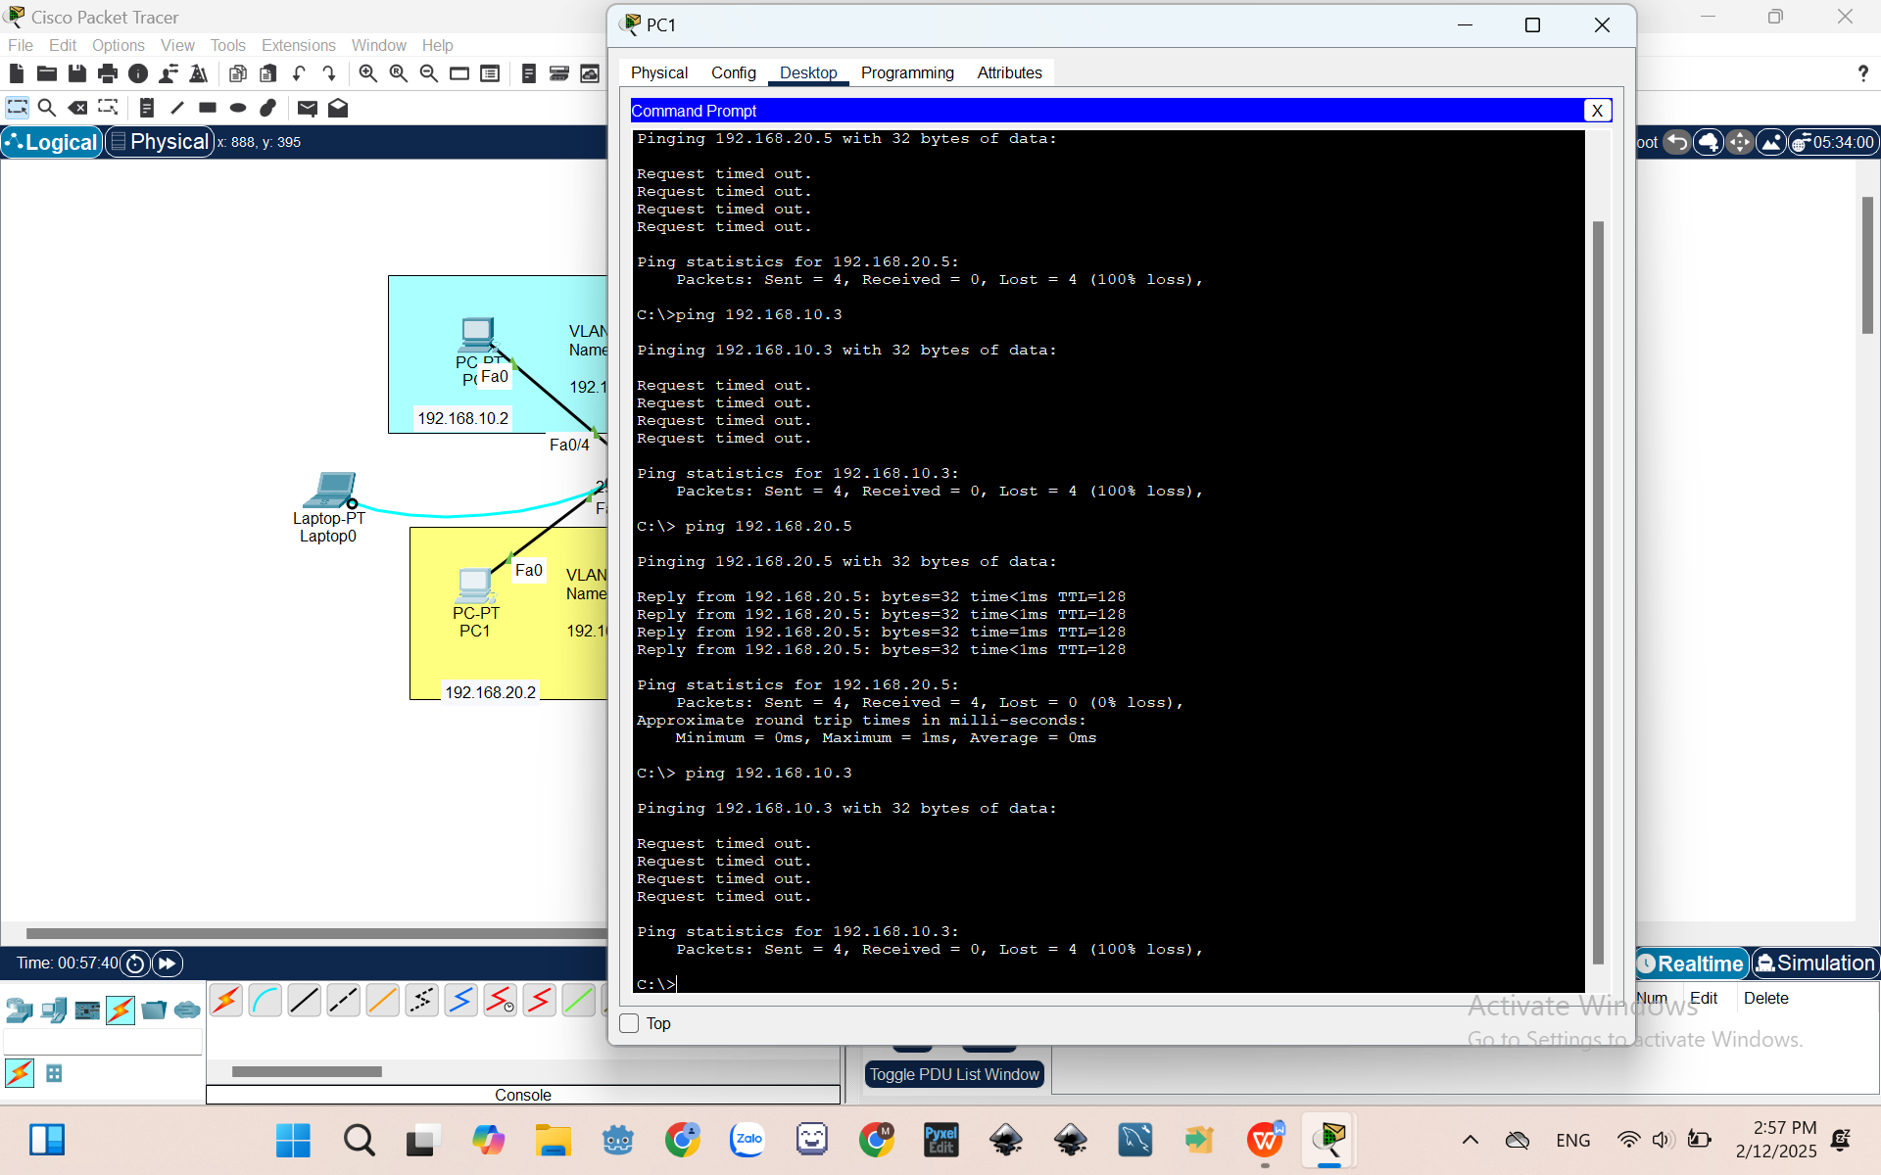
They can connect after trunking the switches
  - Ping PC1 and PC3, then explain the result. Result:
Because they are in different vlans
II.2 DHCP Configuration
- Open Cisco Packet Tracer and implement the network as shown below:
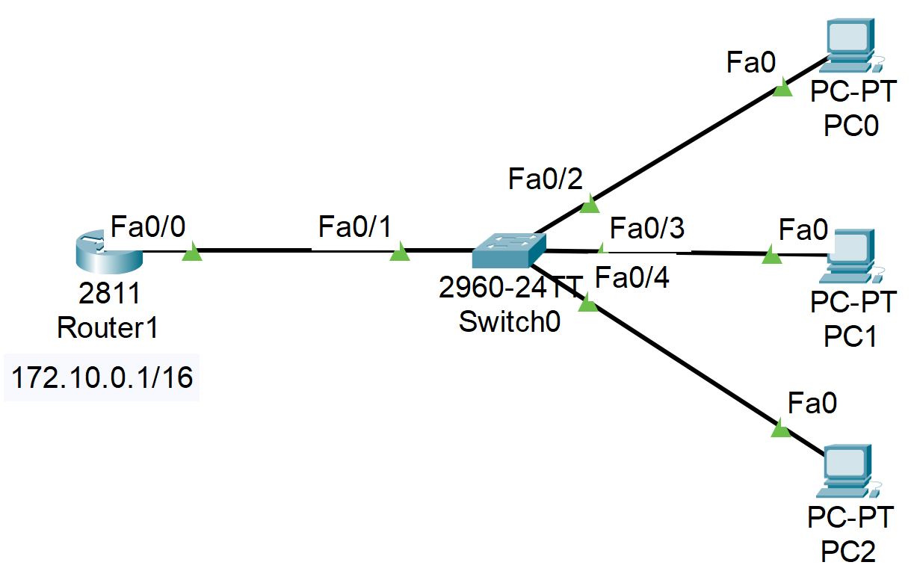
- On the Router:
Router>enable
Router#config terminal
Router(config)#ip dhcp pool net172 | //enter dhcp config mode
Router(dhcp-config)#network 172.10.0.0 255.255.0.0 | //dhcp for network 172.10.0.0/16
Router(dhcp-config)#default-router 172.10.0.1 | //default gateway for PCs client
Router(dhcp-config)#dns-server 203.15.5.6 | //dns for PCs client
Router(dhcp-config)#exit
Router(config)#ip dhcp excluded-address 172.10.0.1 | //do not assign 172.10.0.1 to clients
Router(config)#interface fastEthernet 0/0
Router(config-if)#ip address 172.10.0.1 255.255.0.0 | //set ip for interface fa0/0
Router(config-if)#no shutdown
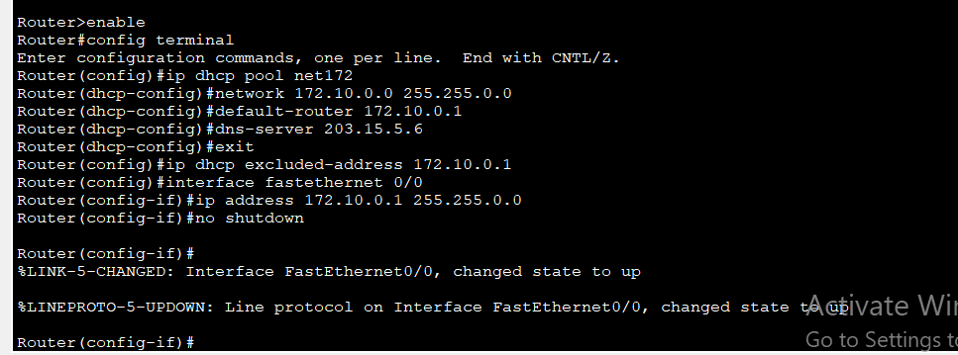
- On the PCs
On PCs, set DHCP on.
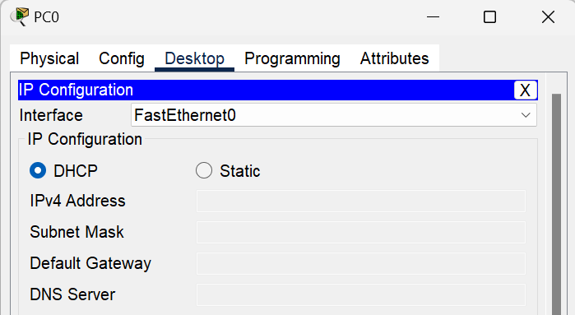
Result:
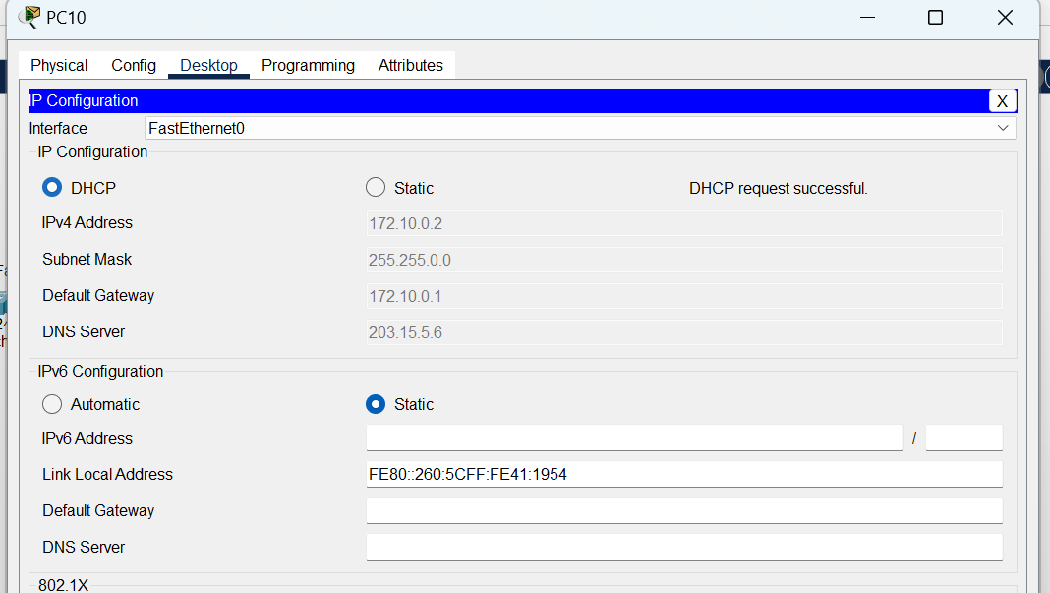
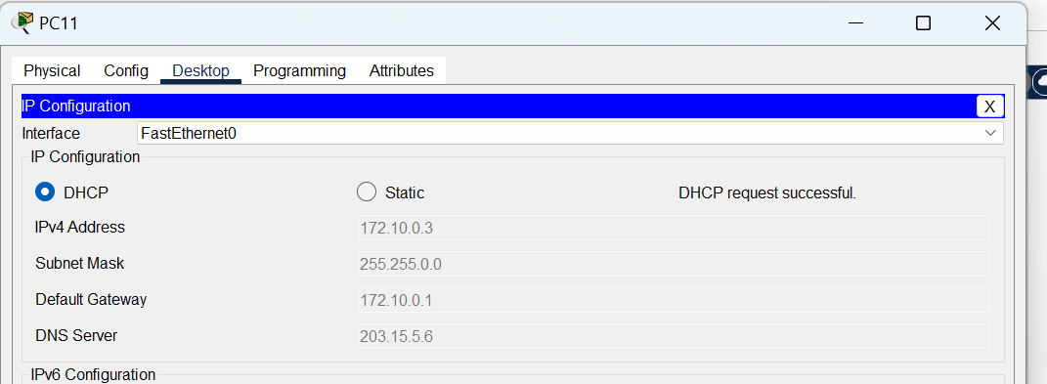
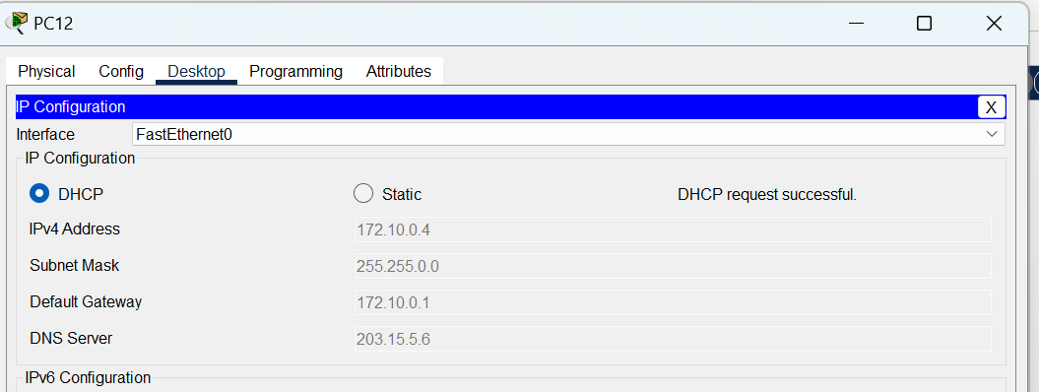
II.3 Connect 2 routers using serial interface
- Add serial interface module for router
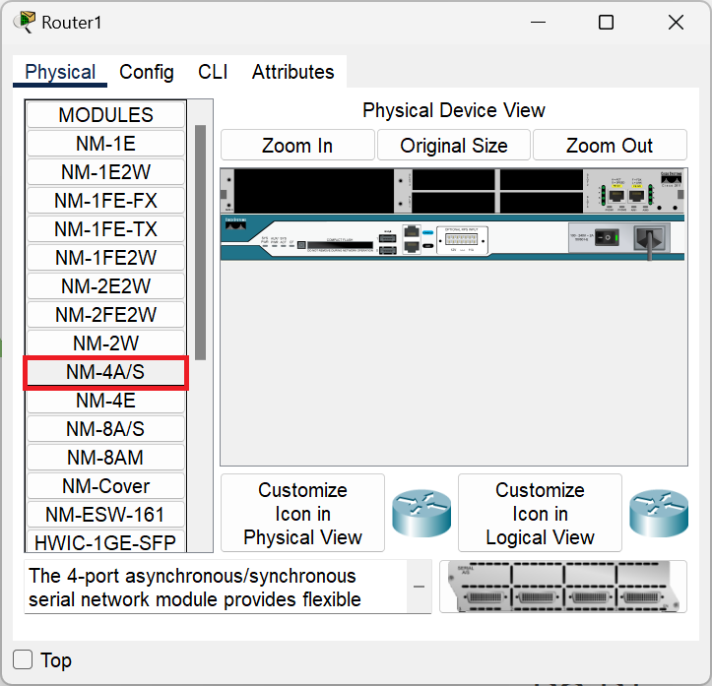
- Connect 2 routers by serial cable
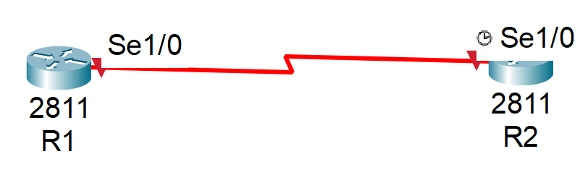
- Configure connection between 2 routers
- On Router R1
Router>enable
R1#config terminal
Router(config)#hostname R1
R1(config)#interface serial1/0
R1(config-if)#ip address 10.0.0.1 255.255.255.252
R1(config-if)#no shutdown
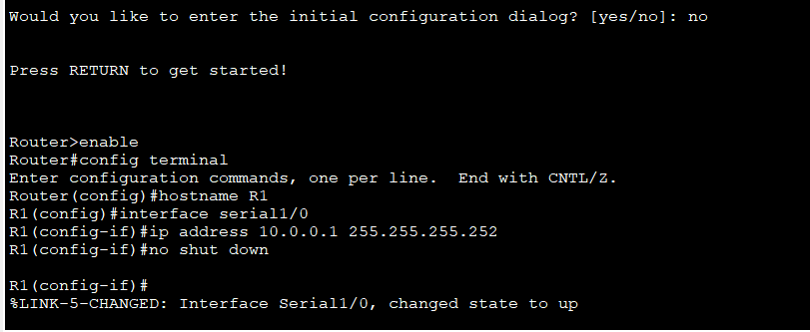
- On Router R2
Router>enable
R2#config terminal
Router(config)#hostname R2
R2(config)#interface serial1/0
R2(config-if)#clock rate 128000
R2(config-if)#ip address 10.0.0.2 255.255.255.252
R2(config-if)#no shutdown
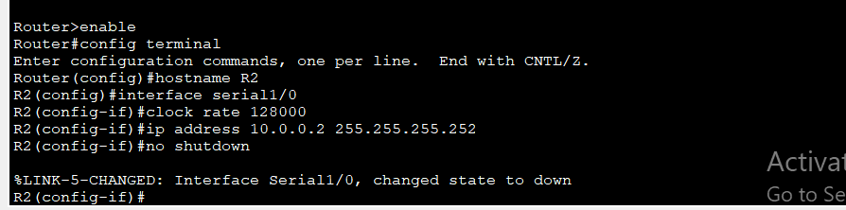

II.4 Static Routing
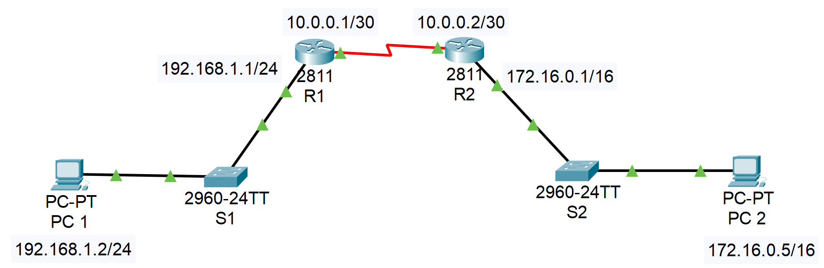
- On Router R1
      - R1 (config)#ip route 172.16.0.0 255.255.0.0 10.0.0.2
      - OR: R1 (config)#ip route 172.16.0.0 255.255.0.0 se1/0
- On Router R2
      - R2 (config)#ip route 192.168.1.0 255.255.255.0 10.0.0.1
      - OR: R2 (config)#ip route 192.168.1.0 255.255.255.0 se1/0
- Show routing table
      - Router#show ip route
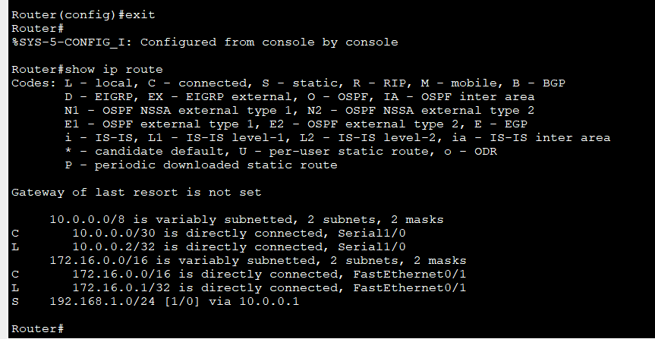
- Result (ping between PCs):
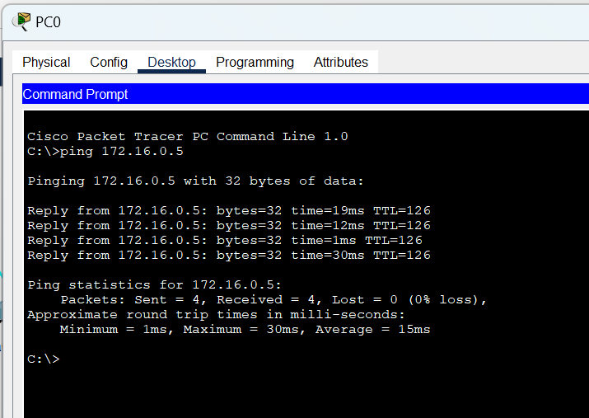

II.5 DHCP & Static Routing
Configure DHCP, Static Route on R1, R2
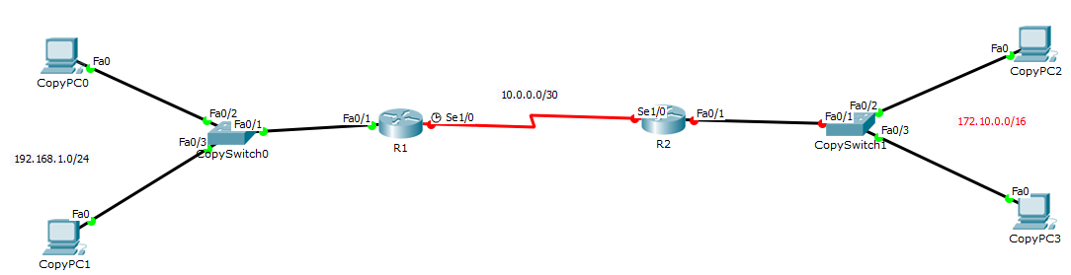
    - Show all configuration commands for each devices
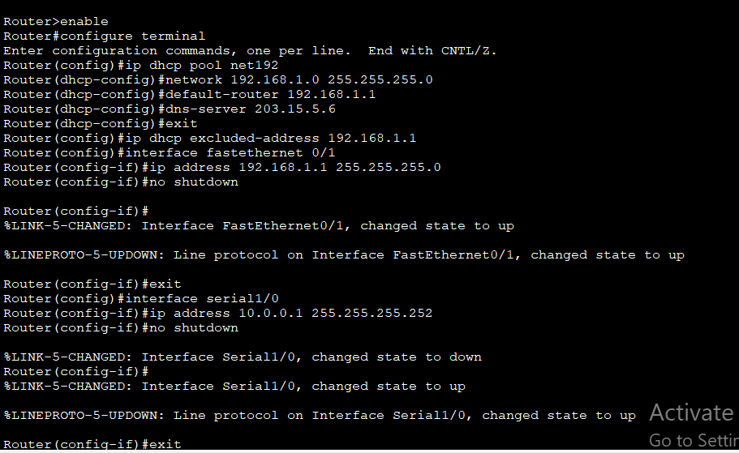
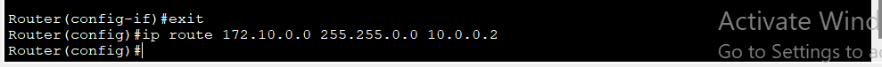
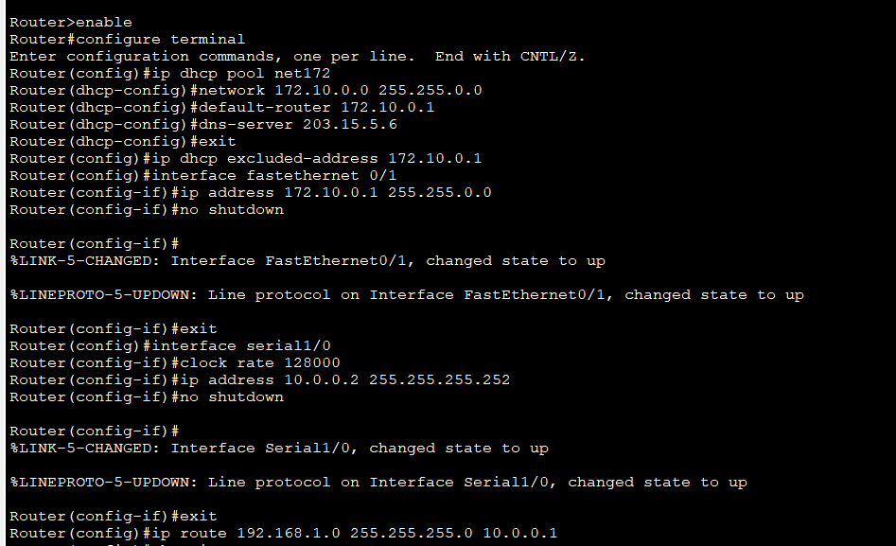
    - Show the routing table on each router.
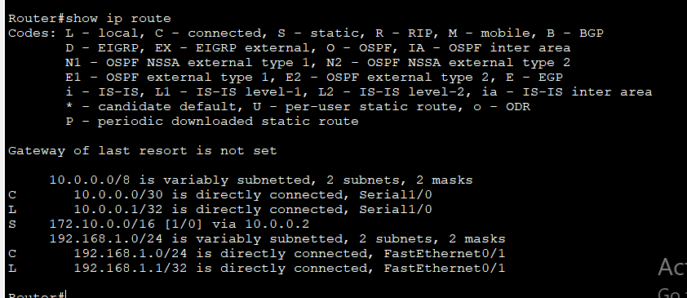
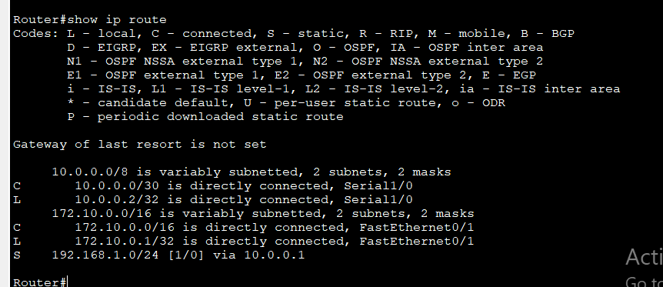

    - Show the result (DHCP and Ping)
